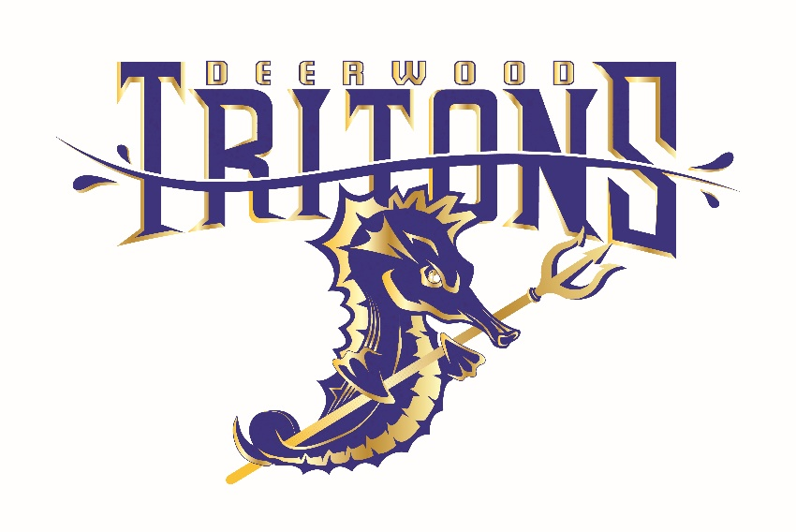

**LOOKING FOR A FUN SUMMER AT THE POOL**

Join the

***Deerwood Tritons Swim Team***

*********************

Make new friends

Competitive swim meets June and July in the South Jersey area

Pool Parties / Team Family Activities / Team Awards Night

*********************

2023 Registration is open

The Tritons welcome all swimmers of all abilities!

To learn more and to request a registration form, please email the Deerwood Tritons at [foreverpoolside@comcast.net](mailto:foreverpoolside@comcast.net) or call 609-330-4881.